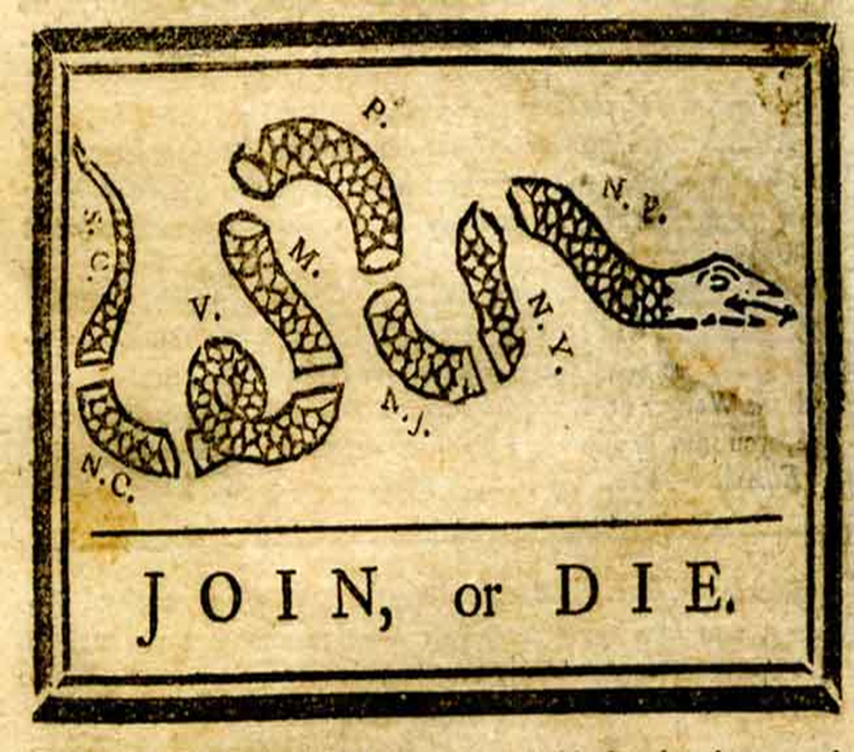
Ben Franklin’s, “Join or Die” political cartoon,1754

